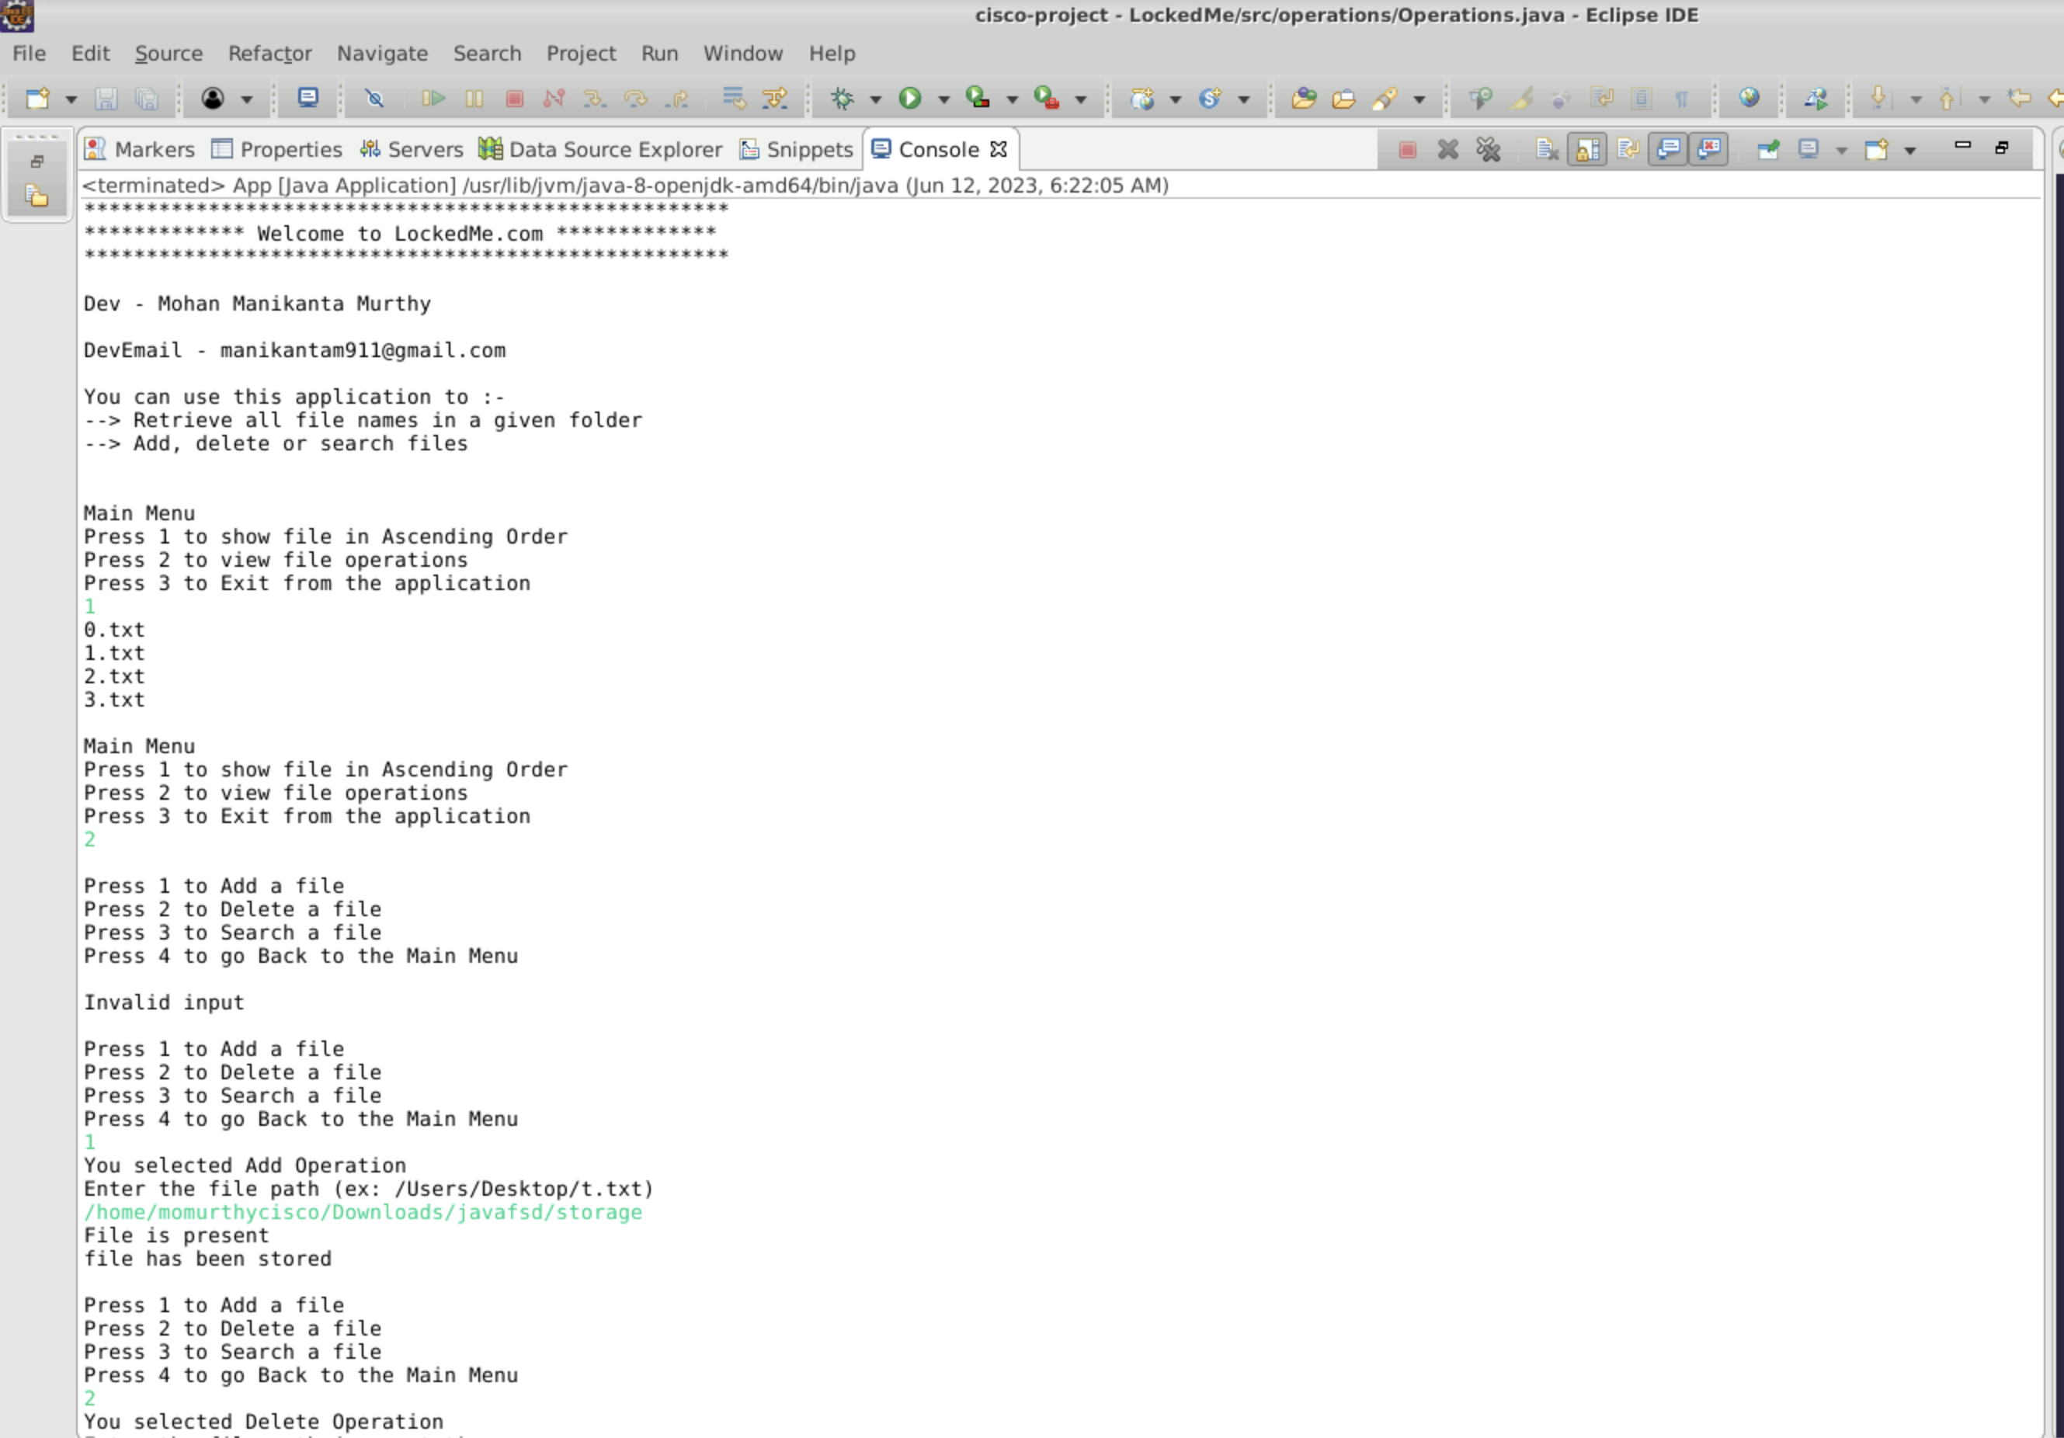

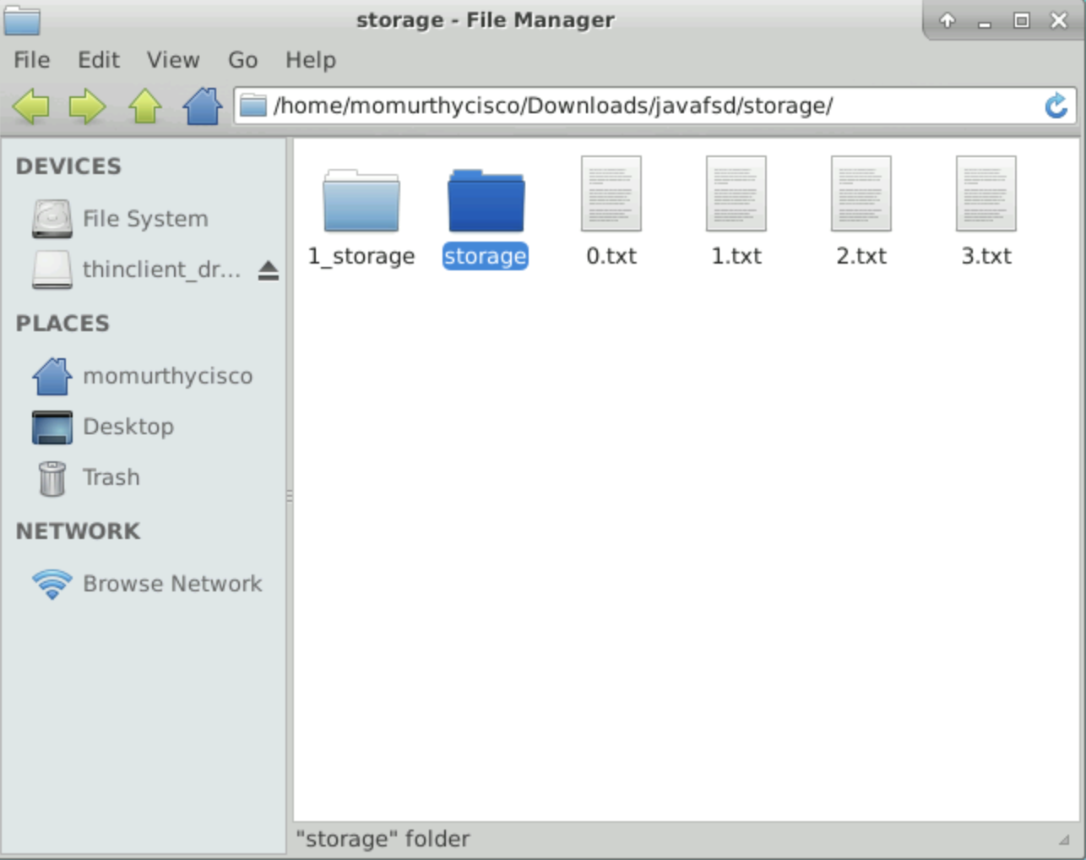

(Storage File added as per above operations)

